**Project 2 Part 2 (square with min area)**

Name: Randy Fu Period: 5

Date: 10/4

Is your lab name l022?(lowercase L followed by digits 022) Yes

Did you comment out the call to part1 method? Yes

Did you create a class for a Point? Yes

Did you create a class for a Line? Yes

List all classes you created in this project: doublePoint, part2, point, Line, makePoints, Circle, part1

Did you use the precision for the points like in the sample? Yes

Did you test your file on a school computer using jupyterhub/ssh? Yes

Did your file compile and run on school computer (jupyterhub)? Yes

Paste here **2 sets of clear picture/content** of the points.txt, output.txt and output.ppm you created when running 2 times your lab :

* one of the runs should be on the sample provided by Mr. Jurj;

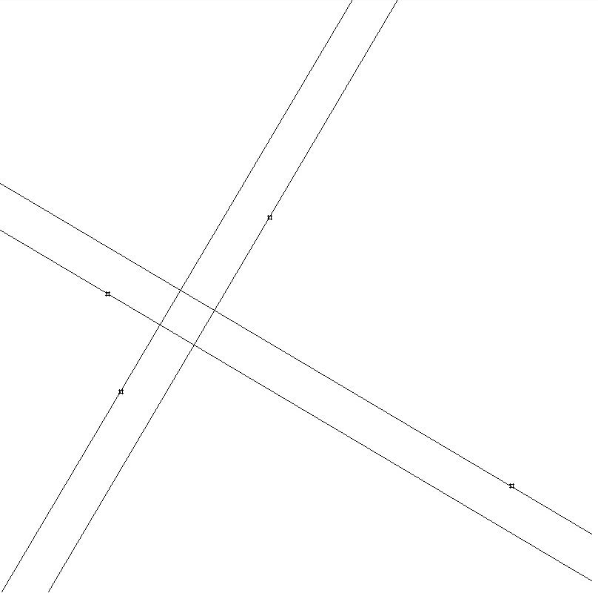

* the other run on a random set of points.txt your part1 generated!! :

